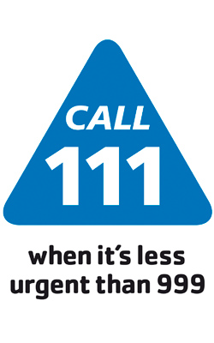

Staff Update:

In May Dr AuYeung left to take maternity leave; she hopes to return towards the middle of December. Sadly Dr Harrison left in May to take up a GP Partnership elsewhere in the city with her husband. We have a new GP joining us in September Dr Katie Horder.

**Contents:**

Coming & Going

Diabetic Eye Screening

Vaccination advice

Boots Micro suction Service

AccuRx

Cambridge Sustainable Food

**How we are coping during the Pandemic**

When the covid-19 pandemic became a reality; we had to move fast to put in place a safe way of working for both patients and staff by carrying out risk assessments. This resulted in several members of staff who came into the high risk categories being released to work from home or told to stay home and shield. We decided to temporarily close the Branch Surgery and have used it for a base for our vulnerable staff to work from. Throughout the pandemic a small but dedicated team of clinicians and admin staff have continued to provide a service for you from the Mill Road premises. GP’s now triage your calls and have set up telephone and video appointments. If a face to face appointment is necessary the staff wear full PPE and all patients are asked to wear a face mask. We ask you to attend appointments if we write and request as we are now beginning to open up appointments for more routine health care like diabetic checks and asthma reviews. The nursing team have continued with baby vaccinations and cervical screening and carrying out blood tests and dressings. When we open again fully you will see a few changes to how we work with special signage to direct you safely around the building and sanitisation stations, we will ask you to enter via the front door and exit via the back. A new intercom system has been installed by the front door allowing reception staff to speak to you.

We thank you for your co-operation while we have been making the transition to a new way of working.



Newsletter

Summer 2020

Mill Road Surgery

279-281 Mill Road

Cambridge

CB1 3DG

Phone: 01223 247812  
**Email:** [admin.millroadsurgery@nhs.net](mailto:admin.millroadsurgery@nhs.net)

Website. [www.millroadsurgery.co.uk](http://www.millroadsurgery.co.uk)

Mill Road Surgery (& Cherry Hinton Branch)

**Parents and carers may be concerned that their baby’s/child’s immune system cannot cope with both COVID-19 and immunisations and that in responding to vaccines, their ability to fight COVID-19 will be reduced/affected.**

Parents and carers should be reassured that as vaccines contain either weakened viruses or only a small amount of the inactivated organism/toxoid, the response uses only a tiny proportion of the capacity of an individual’s immune system. Vaccination will not overload their immune system, does not make them more susceptible to other infections and, if they do contract an infection in the immediate post-immunisation period, or were already incubating one when they were vaccinated, their immune system will still respond to it.

Vaccinating babies reduces the chances of co-infection with COVID-19 and a serious vaccine-preventable disease.

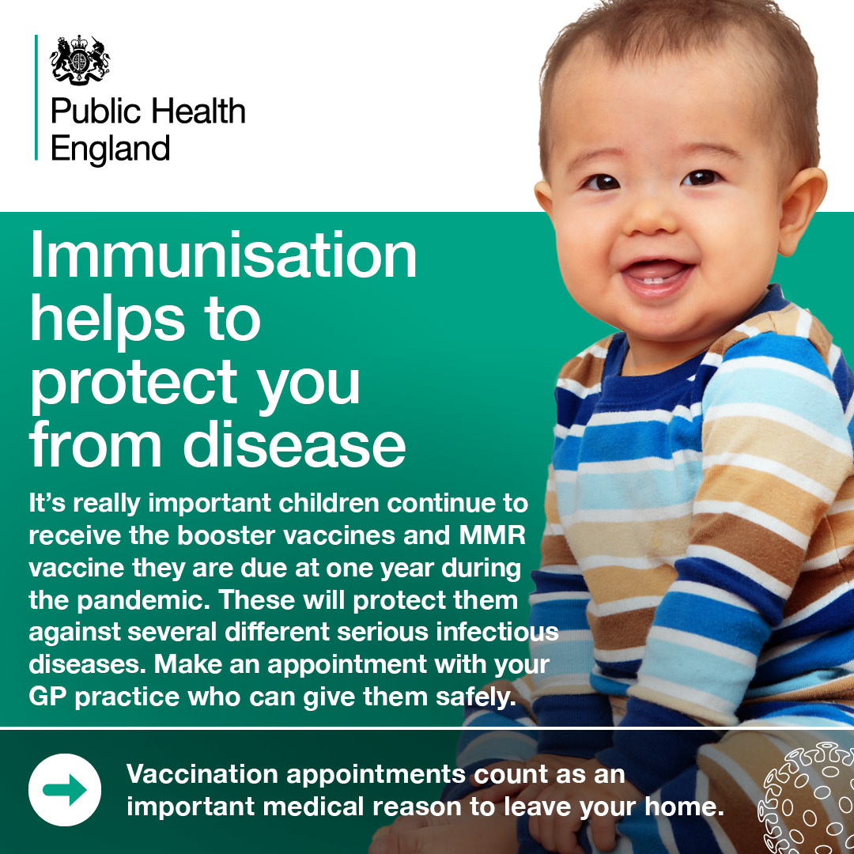

**Baby Vaccinations**

**Guidance to keep you safe when attending your vaccination appointment**   While coronavirus has put limitations on all our lives, it is important that you or your baby or child still have routine vaccinations. They protect against serious and potentially deadly illnesses and stop outbreaks in the community

**Travelling to and from your appointment** When travelling to and from your appointment, please follow guidelines which include travelling by car, bike or on foot if possible, keeping a safe distance from others and washing your hands regularly.

**When attending your appointment** When attending your appointment, we will be putting in place a range of measures to minimise any risk of COVID-19:

* + social distancing measures will be observed;
  + the appointment may take longer than usual.

Due to the ongoing response to COVID-19, our service may have a reduced number of appointment slots available. If you choose not to attend your appointment, please contact your GP practice. It is always helpful for us to know why so we can help you with any concerns you might have. If you still don’t wish to attend the appointment, it can be offered to someone else.

**Diabetes Management**

**Diabetic eye screening: important information about coronavirus (COVID-19)**

**Guidance to keep you safe when attending your screening appointment**    
As a result of the NHS responding to the coronavirus pandemic, you may have waited longer than normal for your diabetic eye screen.

It is important that you now attend your screening test. Delaying your screening further may put you at increased risk of developing diabetic retinopathy (eye disease or sight loss).

**Travelling to and from your appointment**When travelling to and from your appointment, please follow the government guidelines. For more details, go to [www.gov.uk](http://www.gov.uk) and search ‘staying safe outside your home’.

**Wearing a face covering** In line with government advice, when attending your appointment, you must wear a face covering. For guidance on how to wear and make a face mask, visit [www.gov.uk](http://www.gov.uk) and search for ‘face covering’.

**At your appointment please be aware:**

* Your appointment may not be at your usual venue
* Social distancing measures will be in place in the screening clinic
* Staff may be wearing protective clothing to protect you and them
* The screening appointment may take longer than usual.

If you have been shielding because you are clinically extremely vulnerable and you have concerns about the arrangements for your appointment, please contact your local screening service.

Similarly, if you are unable to attend, please contact your local screening service to reschedule your appointment for a different time. This is important so we can offer the appointment slot to someone else who needs it.

**Boots Pharmacies – New Service**

Ear Wax Removal Service costing £50, uses the latest technology and a micro suction technique – developed by ear, nose and throat specialists – to safely, easily and quickly remove ear wax.   
  
A complete service, to make sure both ears are clear and will include a Hearing Health Check. Boots have taken extra precautions in stores and provided their experts with the right PPE to help keep you safe so you can be confident about visiting.  
To book your appointment call 0345 202 7060* or you can book online

**Who should have the flu vaccine?**

You should have the flu vaccine if you:

* are 65 years old or over
* are pregnant
* have certain medical conditions
* Have been shielding at home following government advice or are a carer or member of the household of a shielded patient
* are living in a long-stay residential care home or other long-stay care facility
* receive a carer's allowance, or you are the main carer for an elderly or disabled person whose welfare may be at risk if you fall ill
* children over the age of 6 months with a long-term health condition
* children aged 2 and 3 years
* children in primary school (given at their school)

Children aged between 6 months and 2 years who are eligible for the flu vaccine will receive an injected flu vaccine.

Children eligible for the flu vaccine aged between 2 and 17 will usually have the flu vaccine nasal spray.

For 2020 the government will be including patients aged 50 and over too – please follow press releases for updates on this.

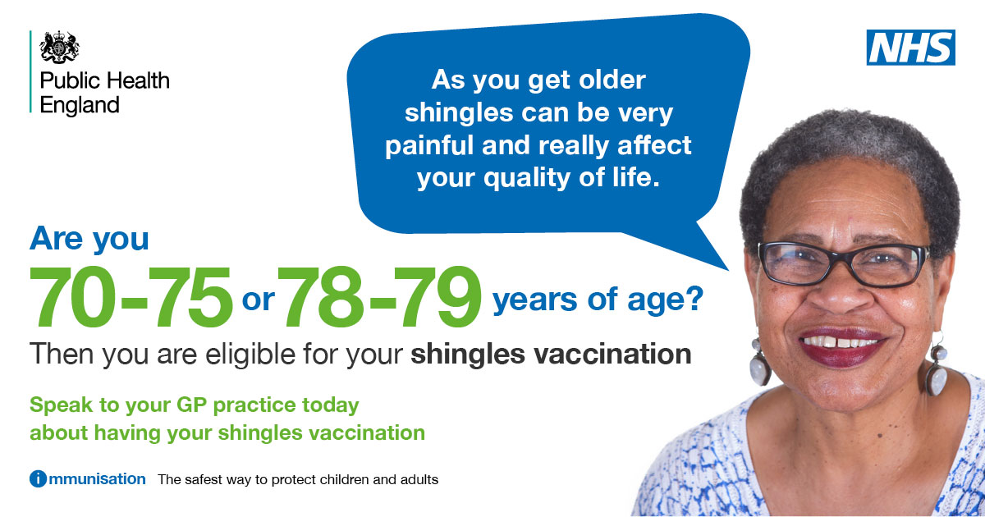



Cambridge Sustainable Food [https://cambridgesustainablefood.org/food-peverty-alliance]

**WHAT IS IT -** According to the [**Centre for Cities 2017 report**](https://www.centreforcities.org/publication/cities-outlook-2017/)**,** Cambridge has been named as the city with the highest level of income inequality in the UK. Cambridge City Food Bank gave 3-day emergency food supplies to 6,458 people in crisis in 2017, a 27% increase from 2016.

If you or someone you know is struggling to buy food please visit the website to see the signposting toolkit. Cambridge Sustainable Food is also partnered with the Edge Café in Mill Road where organisation’s and households can donate perishable food that would have been wasted and make available to the local community

Cambridge City Food Bank:  Phone 07772 538628  Email [info@ccfb.org.uk](mailto:info@ccfb.org.uk)

If you need help from the food bank the quickest way is by telephone to be directed to the most appropriate agency to give you a foodbank voucher.

We are using **AccuRx** to help with GP consultations: If you receive a text from your GP asking you to respond using a link, you should be able to use your phone to do this if you have internet access on your phone (Wifi/3G/4G connection). To reply back you will need to click on the link – this will give you the option to reply back, attach a photo (you cannot upload any photos larger than 5MB). If you can’t use your phone for any reason, you can also use the link to respond on a computer, iPad or tablet. To do this type your unique link from the text into the URL search bar of your internet browser. The link may look something like this: **florey.accurx.com/eXaMple** We can also use this to carry out video conversations with you.

In legal terms accuRx is the Data processor, your GP practice is the Data Controller. This means accuRx don’t own any of your data and wouldn’t pass it on to other companies or use it for marketing purposes.

Video Consultations: All participants are visible during the consultation and it is not recorded or stored on any server.

Useful Contacts:

**Age UK Cambridgeshire & Peterborough, Community Information Network:** provide a single point of access for local information about services for older people and carers in our area. For example; support at home, handyperson service, day centers, and friendship clubs. **Helpline 0300 6669860 o**r email **infoandadvice@ageukcap.org.uk**.

**Caring Together 0345 241 0954** Support for carers of all ages

**Cambridgeshire MIND** call 0300 303 4363 or email [enquires@cpsimind.org.uk](mailto:enquires@cpsimind.org.uk) web information is available on www.cpsimind.org.uk